Year 4: Literacy Week 3 Day 1
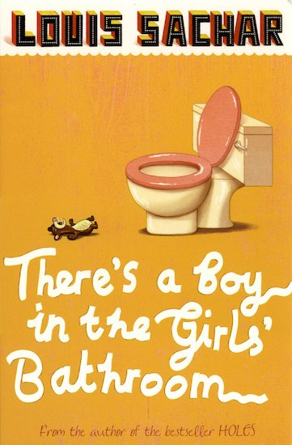
LI: To write a character description for a new character.
Success Criteria
I can describe appearance
I can describe personality
I can use a range of adjectives and conjunctions

Your task is to create a new character to meet Bradley in school. You can choose who they are and why they are in the school.

Think about:
- What they look like
- What their personality is like
- Why they have come to the school

bossy shy embarrassed confident determined friendly
and so if but because however yet
____________________________________________________________________________________________________________________________________________________________________________________________________________________________________________________________________________________________________________________________________________________________________________________________________________________________________________________________________________________________________________________________________________________________________________________________________________________________________________________________________________________________________________________________________________________________________________________________________________________________________________
__________________________________________________________

Year 4: Literacy Week 3 Day 2
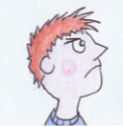
LI: To use dialogue effectively to show two characters meeting.
Success Criteria
I can use inverted commas
I can use synonyms for said
I can use adverbs

Your task is to write the conversation between your new character and Bradley Chalker at school. You can choose where they meet and how each character feels about the other.

Think about:
- Who is speaking?
- What they said
- How they said it
- What actions they were doing to show how they were feeling

“Who are you?” snapped Bradley angrily, as he wandered into the classroom.

Year 4: Literacy Week 3 Day 3
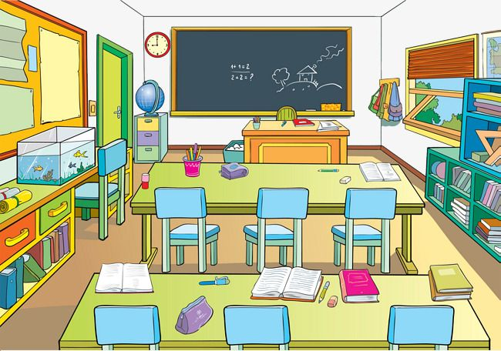
LI: To write a setting description of the classroom.
Success Criteria
I can use my 5 senses (see, touch, taste, smell, hear)
I can use noun phrases
I can use fronted adverbials followed by a comma

Your task is to describe the setting description of where your two characters meet. Think about using your 5 senses to describe the classroom or the playground of the school.

lively chaotic exciting encouraging colourful

____________________________________________________________________________________________________________________________________________________________________________________________________________________________________________________________________________________________________________________________________________________________________________________________________________________________________________________________________________________________________________________________________________________________________________________________________________________________________________________________________________________________________________________________________________________________________________________________________________________________________________
__________________________________________________________

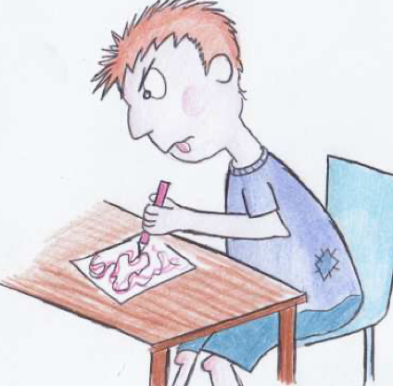
Year 4: Literacy Week 3 Day 4

LI: To plan a dilemma
Success Criteria
I can sequence and order events
I can choose key vocabulary
I can create suspense using fronted adverbials

Your task is to plan a dilemma for your character. You can choose what goes wrong and how your character solves the problem. Think about how your character is feeling at each stage.

What is the problem? E.g. Bradley tells a lie about the new character. What should they do?
What choices could your character make?

What does your character decide to do?
What are the consequences for your character?
What does your character learn from the situation?

Year 4: Literacy Week 3 Day 5
L.I: To write a dilemma
Success Criteria
I can include speech
I can include a range of adjectives and noun phrases
I can include a character and setting description

Your task is to write a dilemma for your new character and Bradley Chalker. You should use your plan from yesterday to help structure your writing into paragraphs.

You must include:
- A setting description
- A character description of your new character
- Speech between the characters
- Explanation of the problem and how it is solved.

________________________________________________________________________________________________________________________________________________________________________________________________________________________________________________________________________________________________________________________________________________________________________________________________________________________________
________________________________________________________________________________________________________________________________________________________________________________________________________________________________________________________________________________________________________________________________________________________________________________________________________________________________
________________________________________________________________________________________________________________________________________________________________________________________________________________________________________________________________________________________________________________________________________________________________________________________________________________________________
________________________________________________________________________________________________________________________________________________________________________________________________________________________________________________________________________________________________________________________________________________________________________________________________________________________________
________________________________________________________________________________________________________________________________________________________________________________________________________________________________________________________________________________________________________________________________________________________________________________________________________________________________
_______________________________________________________________________________________________________________________________________________________________________________________________________________________________________________________________________________________________________________________________________________________________________________________________________________________________

