EYFS Home Learning Pack

Number
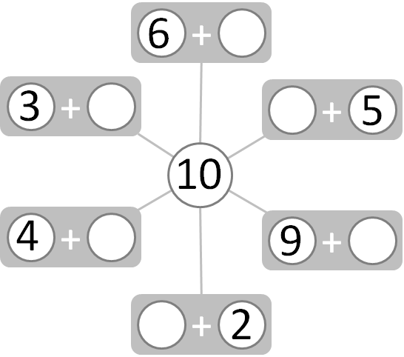
Can you find the number bonds to 10?
Now try to write out the number sentences in the squared grid below. An example has been done for you.
8 + 2 = 10
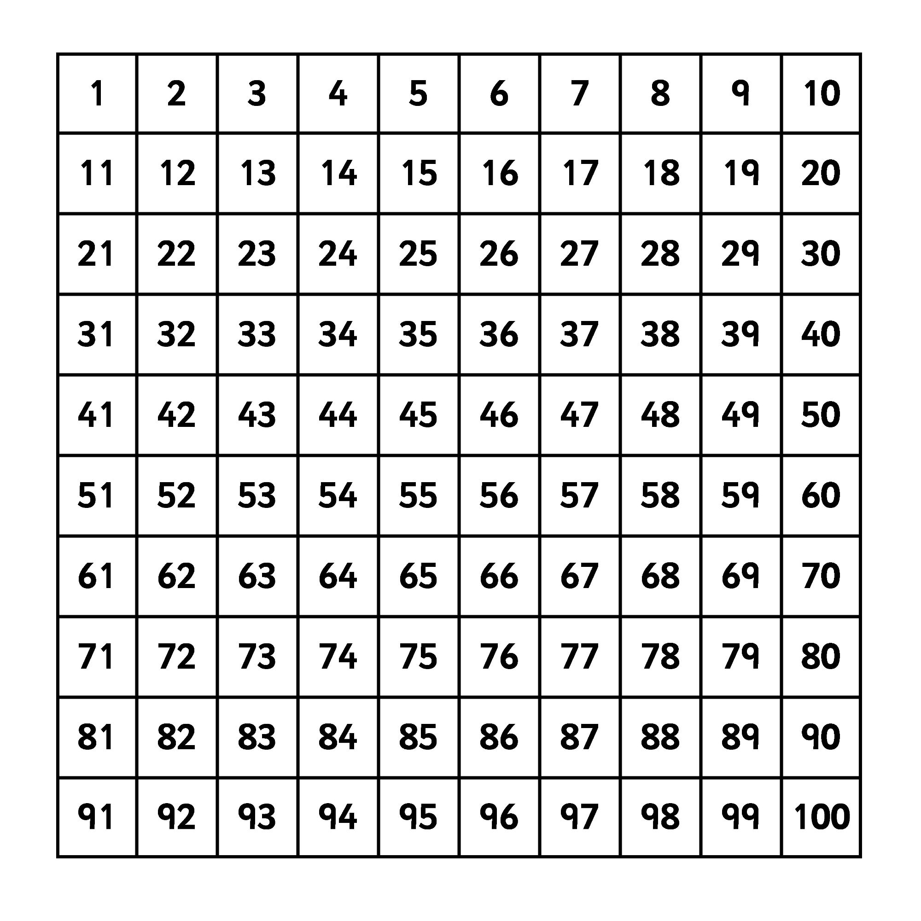
We have been practising to count forwards and backwards from any given number. Ask an adult to point to a number and then practise counting forwards and then backwards from that number.

Now have a go at finding the following answers.

1 more than 6 1 more than 12 1 more than 15
1 less than 6 1 less than 10 1 less than 17
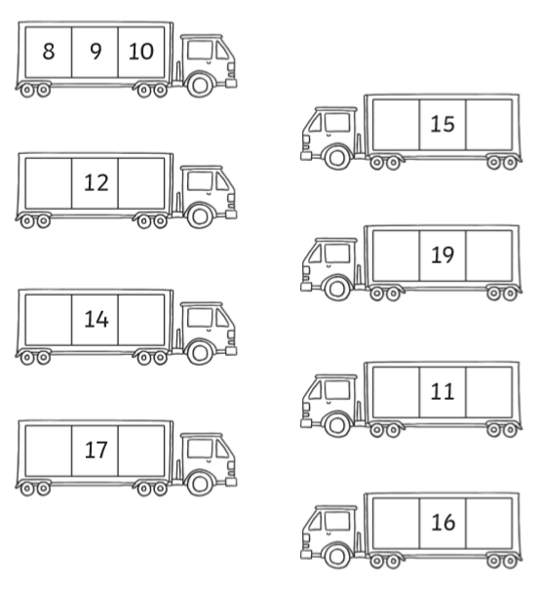
Use the 100 square to complete the number sequence.

Shape Space and Measure

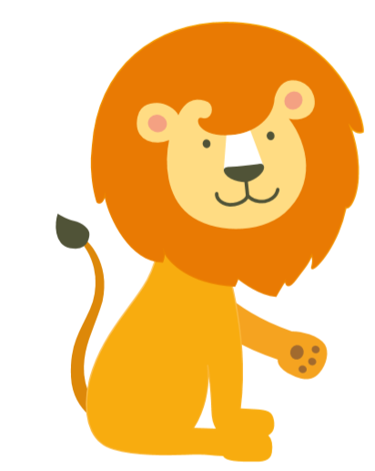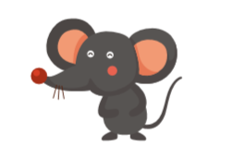

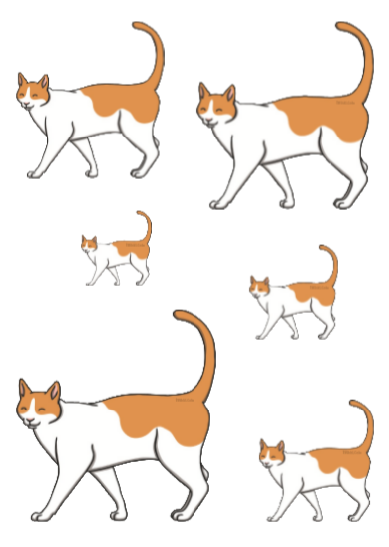
Cut around the cats below and order them from smallest to biggest? Use the key vocabulary to discuss the different sizes.
Activities
- Find your dolls, teddies, play figures etc. Line them up from tallest to the shortest.
- Use a spoon as a measuring device. Go around and see if things are the same size, shorter or longer than the spoon.
- How many strides is the room length? How many steps is it?
- Who is the tallest in your house? Who is the shortest and who is in the middle?
- Draw around your hands. Who has the largest hands? Who has the smallest hands? Which things are larger than a cow? Make a list or draw things.
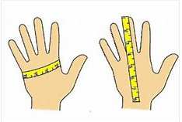

Topic
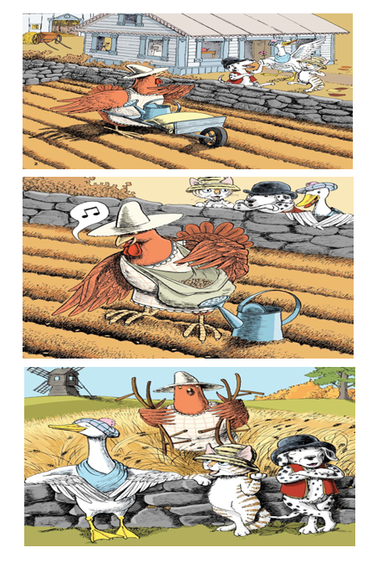
Next half term our topic is ‘On the farm’. Look at the pictures from the book ‘The Little Red Hen’ and discuss what is happening with an adult.
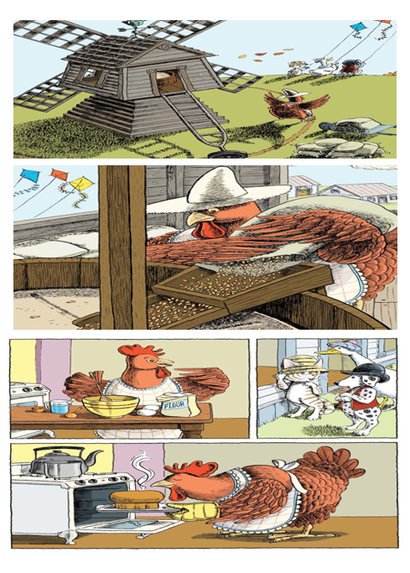
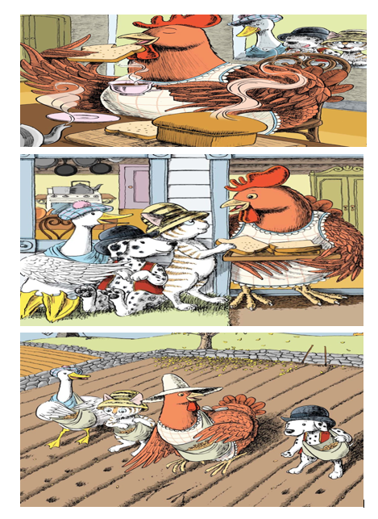
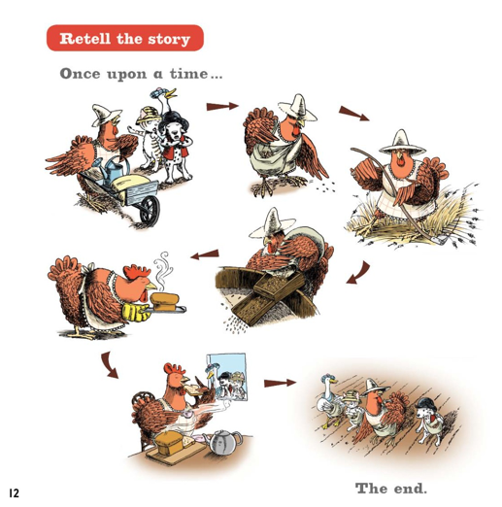
Can you retell the story to an adult using the following time connectives?
Time Connectives
First next then after that finally

Little Red Hen used a variety of ingredients to make bread. Can you write a list of ingredients you need to make bread. If you want to challenge your self further then write a sentnece explaining how to make bread.

