Digital Leaders Meeting Minutes - 23/11/2018 (Orchard site)
Present: Harri (Poplar), Kara (Hawthorn), Marlowe (Laurel), Sumayah (Poplar), Mrs Baez
Point | Item | Discussion/Tasks | Action
1 | Training Update | 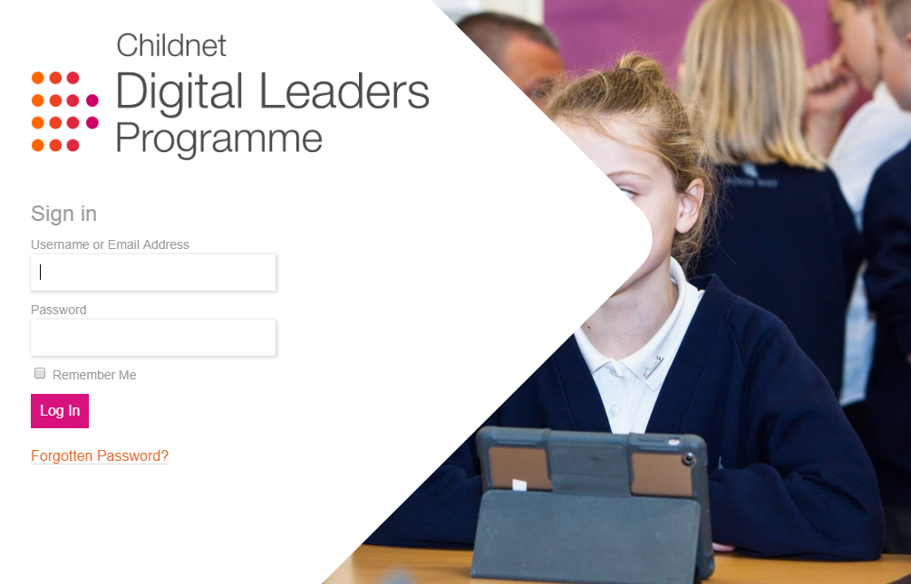  All pupils have completed module 1. | Pupils to complete modules 2-6 with Mrs Baez at Orchard by Friday 21st December  (lunch times, laptops)
2 | Event: Safer Internet Day 2019  Date: Tuesday 5th February  Time: 9am-4.30pm  Location: BT Centre | Theme: Our internet, our choice: Understanding Consent in a Digital World  “In the UK, the campaign is particularly focusing on the role of consent and permission in young people’s online lives and how they navigate the choices they face online. This could be the choice to share a photo or accept a friend request, or a choice to agree to terms and conditions and or control”  On Safer Internet Day pupils will be visiting the BT Centre in London to attend the event which brings together schools, charities, industry and the government to spark a conversation about young people’s experiences online. Invited guests will then be arriving from 2pm and will be joining pupils at the event. This will involve moving around different interactive stations and taking part in short activities.  Activities will be run by digital leaders. An activity must be planned, prepared and delivered by pupils.  All pupils have returned consent forms to attend the event.  Discussion around ideas/way to present at event:  - Questions/Challenges for Google/Facebook about parental consent (Marlowe)  - Ideas to present about the impact of current consent online on the future generations (Harri)  - How to teach parents how to understand consent (Sumayah/Kara) | Digital Leaders have all been set homework: how are we going to present to visitors on the day? (powerpoints/posters/  questionnaires/film/other?  Tuesday 8th January 2019, 2pm.  Ellie Proffitt from Childnet will visit Orchard to meet the Digital Leaders to support/review their progress with the presentation so far.
3 | Friday 30th November  E-Safety Coffee Morning with EH | The Digital Leaders will support ICT lead EH with his coffee morning on E-Safety. | Pupils to meet SB and EH on 28.11.18 at 1pm (Redwood) to plan and prepare for coffee morning.

